## Lawson POS HUB2.0 Stress Testing

1. Environment

Mock YoRen Service

POS Client

POS hub 2.0

Mock KargoHub

Server Specification

CPU: 8 cores

Mem: 8G

Client Specification

CPU: i5 9400 3.7G

Mem:16G

1. Scenario
   * Request uploadgoodsdetail(without member no)

Assert responseCode=0000, pay_code=038

* + Request barcode(without yoren member no)

Assert responseCode=0000、pay_code=038, biz_type=02

* + Request uploadgoodsdetail(with Lawson member no)

Assert responseCode=0000, pay_code=038

* + Request barcode (with wechat pay)

Assert responseCode=0000、pay_code=050, status=1000

* + Request tradeconfirm(with Lawson member no)

Assert responseCode=0000, pay_code=038, status=1000

1. Strategy

There are 100 threads，start 20 threads every 30 seconds and hold for 600 seconds, stop 10 threads every 10 seconds finally

1. TPS

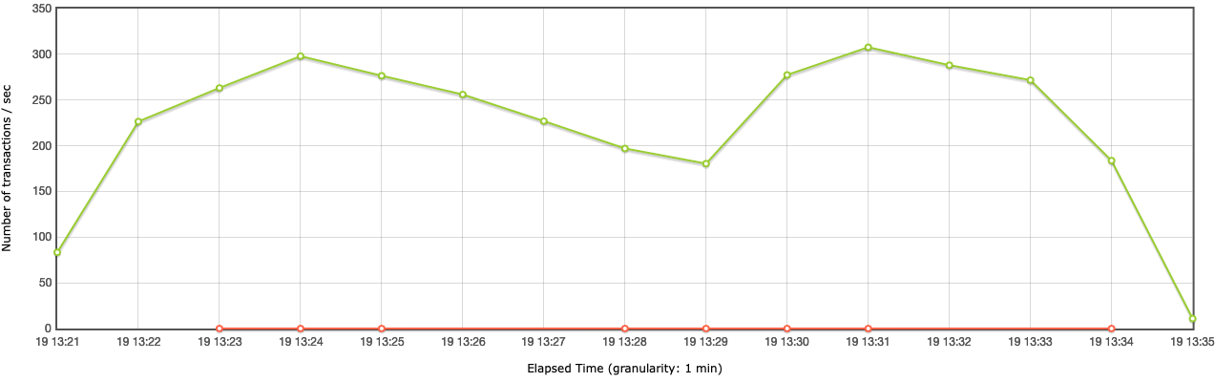

1. Response Time

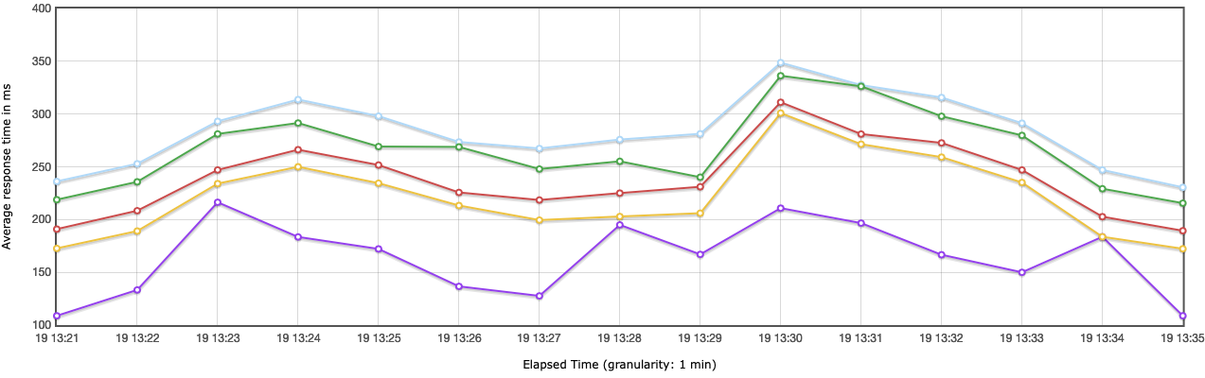

1. Samplers

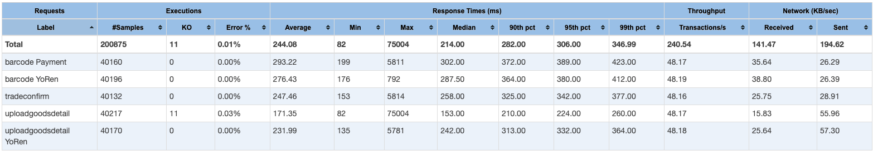

1. POS Hub 2.0 Server resource

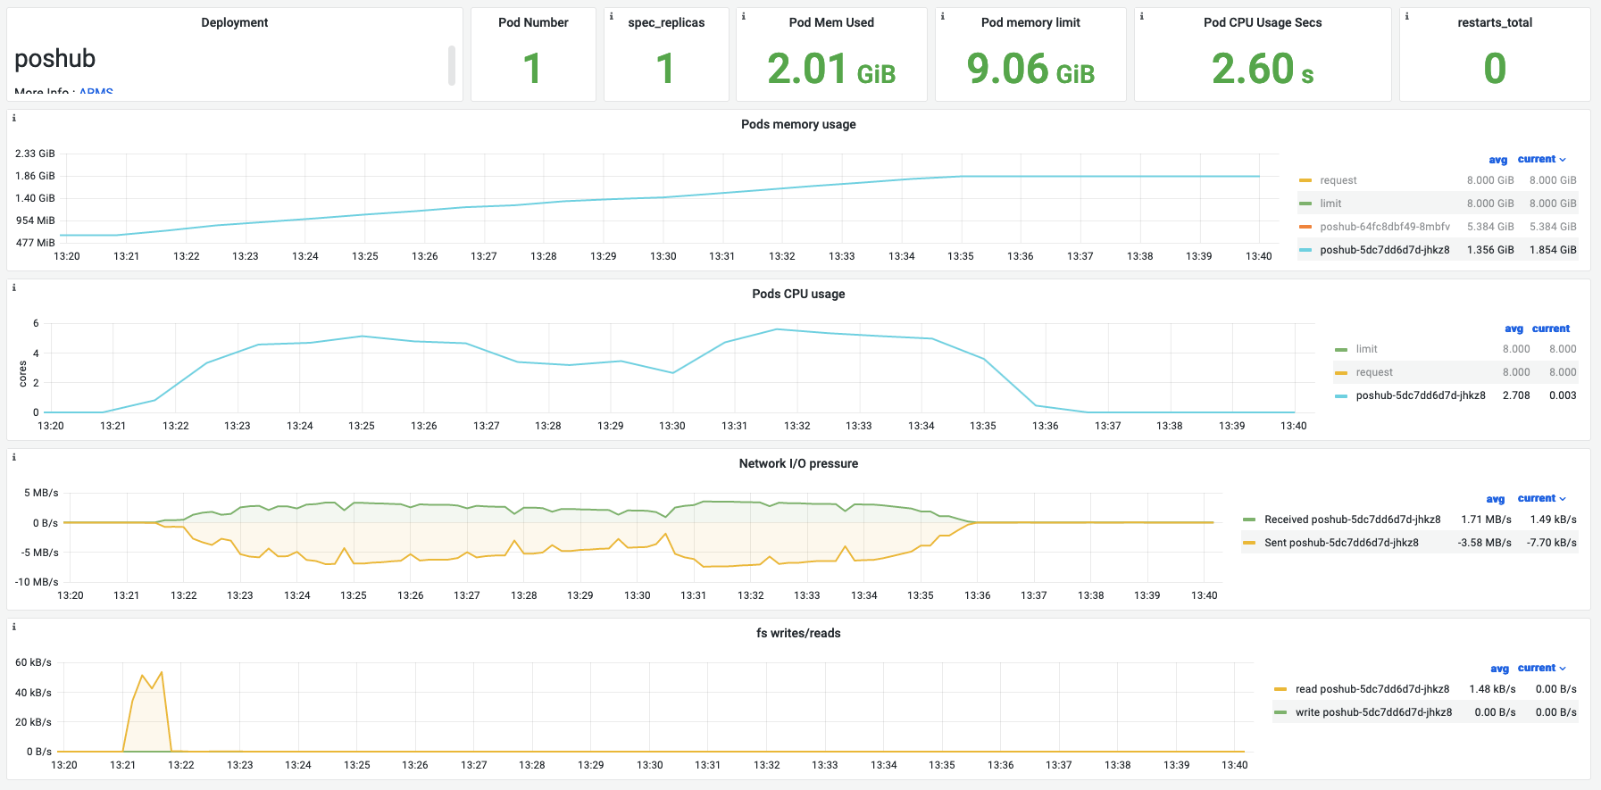

1. Result analysis

The max TPS is at 307 per seconds，avg TPS is at least 240 per seconds。

As far as a transaction, each api’s tps is about 48 per seconds。

From response time, 90% requests are less then 0.2s; 99% requests are less than 0.4s, as the response time chart illustratesthat no sharp fluctuation shows up.

The test totally request 200875 and 99.99% are succeeded response to client, 0.01% are failed due to Connection timed out

From server statistics, CPU usage is below 30%, memory is about 1.3G

Moreover, we have ran 100 threads in 2 hours long and server condition was stable no exception raised

This week we have ran 16 rounds of testing, the each test result gap is not obvious, thus this result indicate a realistic performance